**CL-1002**

**Programming Fundamentals - Lab**

**Lab # 14**

|  |
| --- |
| **Objectives:**   * Loops/Nested Loops * 1D arrays * 2D arrays * Strings * C-Strings /Character arrays * Functions * Practice tasks |

**Note: Carefully read the following instructions (***Each instruction contains a weightage***)**

1. Use proper **font family** and **font size** of **heading**, **sub heading** and **normal text**.
2. First think about statement problem then write/draw your logic on copy.
3. Attach the screen shots of your code in word file with execution (cpp project).
4. File (Word) tittle should in proper format (**23F-1001-Lab2**)
5. You have to submit both (**word + Project in zip/archive**) files.
6. **Upload separate word file and archive/zip of your project.**
7. **50% marks would be deducted on wrong formatting.**
8. **No submission will be accepted after deadline.**
9. Do not copy from any source otherwise you will be penalized with negative marks.
10. Complete your lab **within given Time Slot**.

* Create separate header files for your functions.

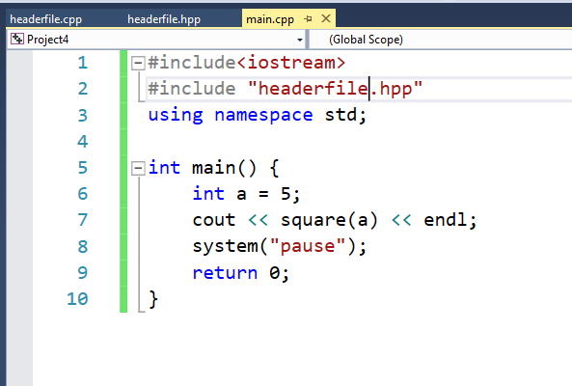

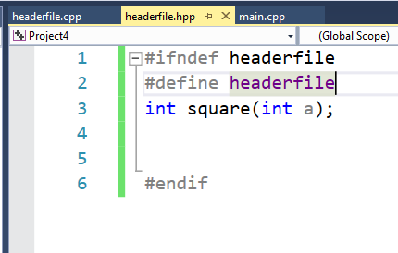

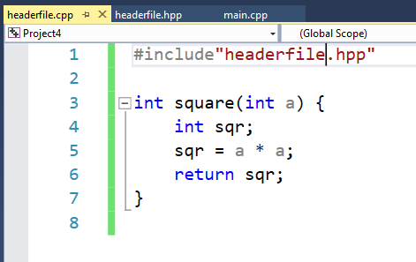

**Problem: Write C++ code for the following statements**

1. **Write a value-returning function, isVowel, that returns the value true if a given character is a vowel and otherwise returns false. (Marks 5)**
2. **Write a C++ program that input marks from students and pass marks to function, then function should return the grade s as per below mentioned criteria:**

**80-100 Grade A**

**70-80 Grade B**

**60-70 Grade C**

**55-60 Grade D**

**50-55 Grade E**

**Otherwise Grade F (Marks 5)**

1. **Write a C++ function that accept two numbers and swap them. Display numbers before and after swapping in main(). (Marks 10)**
2. **Write a C++ program that convert decimal number to binary using function. (Marks 20)**
3. **Write some user-defined functions in C++ for each separate tasks, reverseDigit, countDigit and largestDigit that takes an integer as a parameter and returns the required output.**

* **reverseDigit returns the input digit in reverse order. For example, the value of reverseDigit(12345) is 54321; the value of reverseDigit(5600) is 65; the value of reverseDigit(7008) is 8007; and the value of reverseDigit(-532) is -235.**
* **countDigit return the total number of digits presents init. For example, the value of count Digit(12345) is 5. Total count 5.**
* **largestDigit returns the largest digit present in it. For example, the value of largest Digit(1258) is 8. (Marks 10+10+10=30)**

1. **During the tax season, every Friday, the J&J accounting firm provides assistance to people who prepare their own tax returns. Their charges are as follows:** 
   1. **If a person has low income (< = 25000 ) and the consulting time is less than or equal to 30 minutes, there are no charges; otherwise, the service charges are 40% of the regular hourly rate for the time over 30 minutes.**
   2. **For others, if the consulting time is less than or equal to 20 minutes, there are no service charges; otherwise, service charges are 70% of the regular hourly rate for the time over 20 minutes.**

**(For example, suppose that a person has low income and spent 1 hour and 15 minutes, and the hourly rate is $70.00. Then the billing amount is 70.00 0.40 (45 / 60) ¼ $21.00.) Write a program that prompts the user to enter the hourly rate, the total consulting time, and whether the person has low income. The program should output the billing amount. Your program must contain a function that takes as input the hourly rate, the total consulting time, and a value indicating whether the person has low income. The function should return the billing amount. Your program may prompt the user to enter the consulting time in minutes. (Marks 25)**

1. **During winter when it is very cold, typically, everyone would like to know the windchill factor, especially, before going out. Meteorologists use the following formula to compute the windchill factor, W:**

**W = 35.74 + 0.6215 * T - 35.75 * V 0.16 + 0.4275 * T * V 0.16,**

**where V is the wind speed in miles per hour and T is the temperature in degrees Fahrenheit. Write a program that prompts the user to input the wind speed, in miles per hour, and the temperature in degrees Fahrenheit. The program then outputs the windchill factor. Your program must contain at least two functions: one to get the user input and the other to determine the windchill factor. Bonus task (Marks 25)**

---------------------------------------------------------------------------

Best of Luck 

***"It is better to fail in originality than to succeed in imitation." — Herman Melville***